FiboPlusWaveRunner
Table of contents
Setting up 2
Setting the font for wave markup 2
Automatic markup update 2
Data refresh on first launch 3
Updating versions 3
Short description 4
Features: 4
Buttons 5
Panels 7
Manual trading. 7
“Sell” button. 7
“Buy” button. 8
Auto trading. 9
Parameters 10
Reopening example for EUR / USD 11
Reopening example for GBP/USD 11
Video 12
Questions and answers 13
Wave counting update. 13
The size of the deposit. Lot volume 13
After purchasing the FiboPlusWaveRunner Expert Advisor, is it enough to connect it to the instrument with the same default settings? 14
Which of the following pairs EURUSD, GBPUSD, AUDUSD, XAUUSD (GOLD), EURGBP, USDCAD, USDCHF, EURJPY, USDJPY, GBPJPY, OIL WTI, SPX 500 is most recommended for trading with your Expert Advisor? 14
What to do, if wave counting is not shown on the instrument (symbol)? Is it on the list of 12 pairs, is the display of historical and current waves enabled? 14
How do you know when an auto trade is working? 15
Automatic trading no work? 16
Opening orders for auto trading. 17
Why didn't the signal work for me during auto trading on M15, but did it open when changing to the H1 timeframe? 17
Closing an order when TP 0 is reached. 18
The EA is displayed on the chart differently from the description on the website. 18
Are those EA auto open the order by placing BUY / SELL, or the user need to open it by manually like u show in earlier of your video? "in minutes 1:33" im so confused 18
Download description 18

Setting up

Setting the font for wave markup
for comfortable work, you need to install the EliotWaveMine font
- Download font http://traderevolution.ru/upload/EliotWaveMine.ttf or https://www.FiboPlus.ru/EliotWaveMine.ttf or
https://www.FiboPlus.ru/EliotWaveMine.rar
Place the font file anywhere on the disk.
- Click on the downloaded file 2 times - INSTALL () font
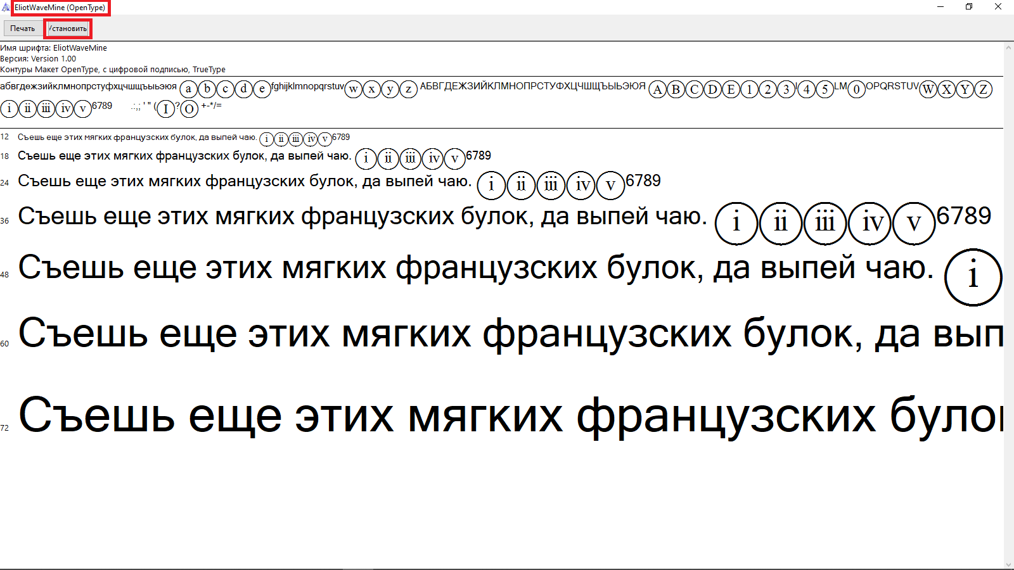

Automatic markup update
To automatically update the markup, you need to add the site to the list of allowed
in the settings of MetaTrader 4 Ctrl+O (Tools -> Options -> 'Expert Advisers' tab)
v - Allow WebRequest for listed URL: https://www.fiboplus.ru/
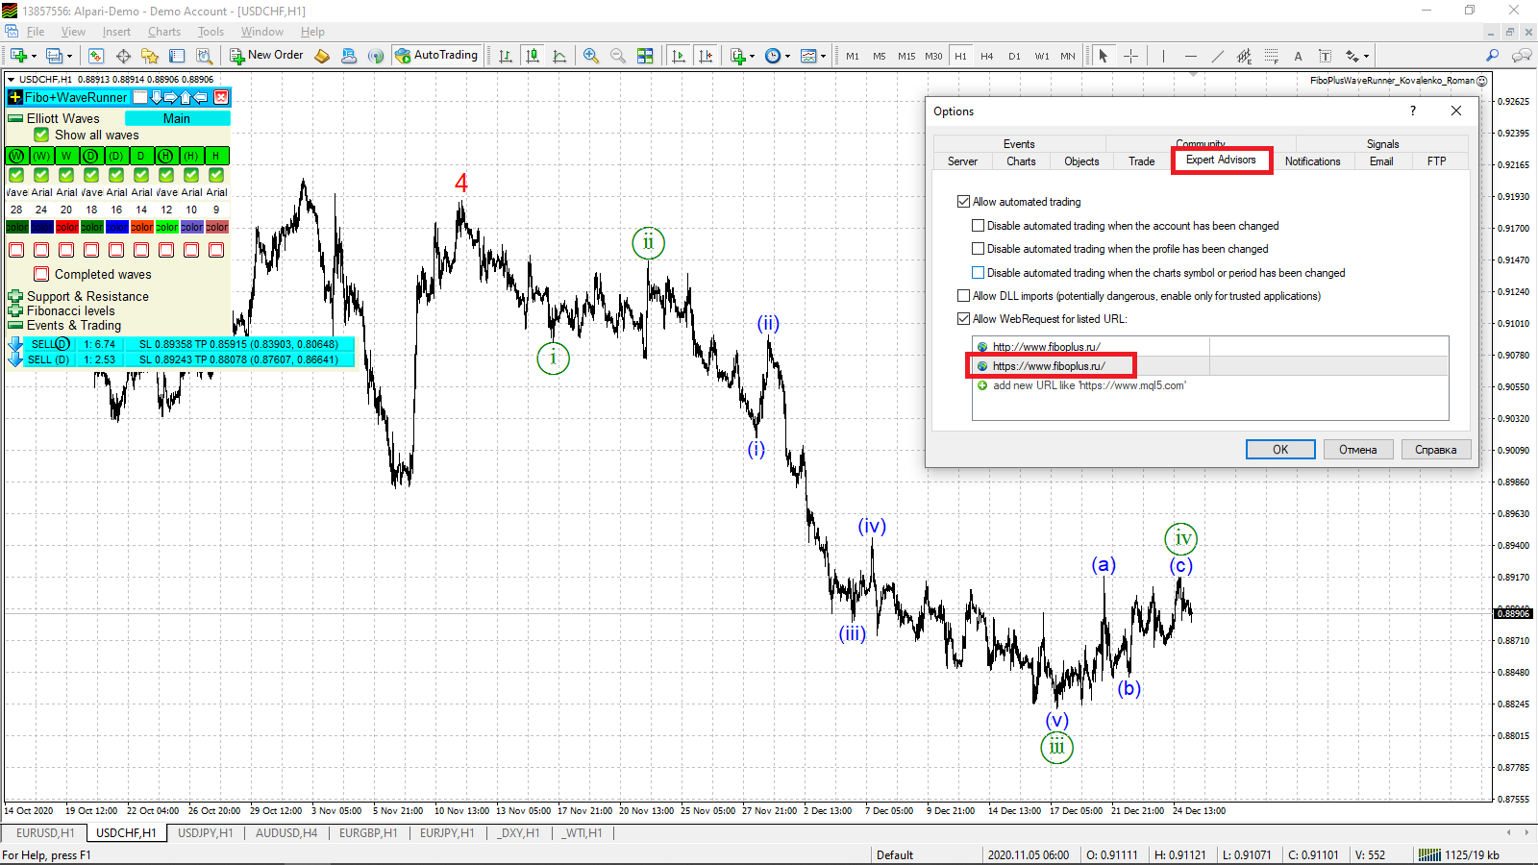

Data refresh on first launch
It is recommended to update the data (successively clicking on the periods M1, M5, M15, M30, H1, H4, D1, W1, MN) before applying the utility to the current chart of the instrument.

Updating versions
You can read the update procedure here https://www.mql5.com/en/blogs/post/734585

After the author has released an update to his adviser, you have the opportunity to receive this update for FREE.
Attention : If you do not receive a button " UPDATE, " but you are confident that our EA came out with an update,
You can to remove our EA from the terminal and retry a new installation ( without loss of activation )!
Or wait until the update is available in the terminal (1-3 days) Updates in MT4 are always late. The terminal is updated once a day.

Short description

Expert. Automatic and manual trading.
Ready-made trading system based on Elliott waves and Fibonacci retracement levels. It is simple and affordable.
- Display of the marking of Elliott waves (main or alternative option) on the chart.
- Construction of horizontal levels, support and resistance lines, a channel.
- Superposition of Fibonacci levels on waves 1, 3, 5, A
- Alert system (on-screen, E-Mail, Push notifications).
- visual panel for opening orders in manual trading.
- visual panel for setting up automatic trading.

Features:
- without delving into the Elliott wave theory, you can immediately open one of the possible options for entering the market with a ready Stop loss (SL possible loss) and Take profit (TP profit) and see its graphical display. (Events & Trading Button.)
- display of waves of the desired wave level (W, D, H) on any period of the chart, setting font types, font sizes, colors of any wave
- forecast of market development with reference points, range of entry and exit points
- position risk assessment (calculation of the profit factor for the first goal)
- daily, at least, updates of the wave markings on the chart from the website or through the exchange file (in any electronic way)
12 tools - EURUSD, GBPUSD, AUDUSD, XAUUSD (GOLD), EURGBP, USDCAD, USDCHF, EURJPY, USDJPY, GBPJPY, OIL WTI, SPX 500 (US500 Standard & Poor's 500)

Buttons

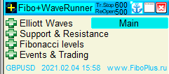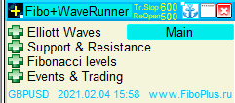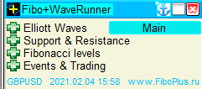
Button «Fibo + WaveRunner». Enabling / disabling auto trading mode.
Current values Tr. Stop 600 (Trailing Stop), ReOpen 500 (ReOpening) are displayed in the menu header.
Tr. Stop, ReOpen - Black color (on, it matters, auto trading does not work).
Tr. Stop, ReOpen - Yellow color (enabled, meaningful, it means they are taken into account in auto trading, auto trading works).
Tr. Stop, ReOpen - empty field (not included, which means they are not taken into account in auto trading).

Anchor Button . Move the expert menu to any point on the screen.
(Click on the anchor icon with the left mouse button, without releasing the button, move the anchor to a new location on the chart, release the left mouse button)
Button to change the style of the color environment.
“X” button. Removing the utility from the current chart.
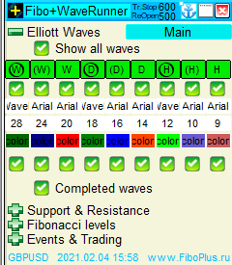
“Elliott Waves” Button.
- “Main/Alternative” - selection of the wave marking display option.
- “Show All Waves” - to show all current waves.
- ( [W], (W), W, [D], (D), D, [H], (H), H ) columns ‒ setting for each wave:
  - to show/hide current wave
  - font installation
  - font size in points
  - wave color
  - to show/hide the completed wave.
- “Completed Waves” - to show all completed waves.

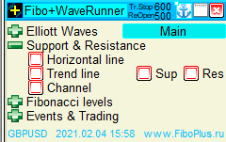

“Support & Resistance” button.
- “Horizontal Line” ‒ construction of horizontal levels (fractals and RSI).
- “Trend Line” ‒ trending line building (RSI)
  - “SUP” support.
  - “RES” resistance.
- “Channel” ‒ a channel construction (waves 1-3, 2-4).

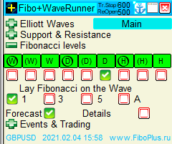

“Fibonacci retracement levels” button.
- ( [W], (W), W, [D], (D), D, [H], (H), H ) columns ‒ a selection of the wave with which the actions will be performed:
  - “1” ‒ apply Fibonacci to 1 wave
  - “3” ‒ apply Fibonacci to 3 wave
  - “5” ‒ apply Fibonacci to 5 wave
  - “A” ‒ apply Fibonacci to A wave
  - Forecast ‒ to show the forecast of price movement
  - Details ‒ in more detail

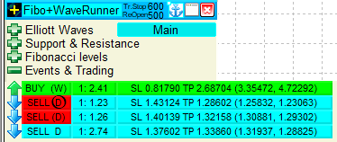
“Events & Trading” Button.
Current trading signals or the message “no entry points”.
Built-in Alert system (on-screen, E-Mail, Push notifications). Settings allow you to set the number and frequency of repetitions.
  - “Bell” button ‒ the arrival of a new alert. After the time has passed, it changes to the Buy (Sell) icon. You can manually switch to the Buy (Sell) icon without waiting for the time to expire
  - “Buy”, “Sell” buttons. Opening orders.
  - Button ‒ signal profitability or profit factor (1: N.NN). The ratio of one part of the loss to N.NN parts of the possible profit.
  - “Sl, TP” buttons ‒ information for opening orders
Pressing any of the buttons “Buy”, “Sell”, the profitability of the signal, “Sl, TP” allows you to show/hide the target price movement.

Panels

Manual trading.

“Sell” button.
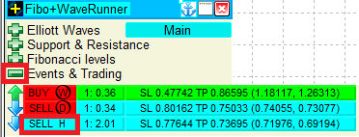
“Events & Trading” Button.
“Buy”, “Sell” buttons. Opening orders.

Lot - 0.01, Spread, Fibo, show Fibo. Visually shown are 3 orders with targets (TP0, TP1, TP2).
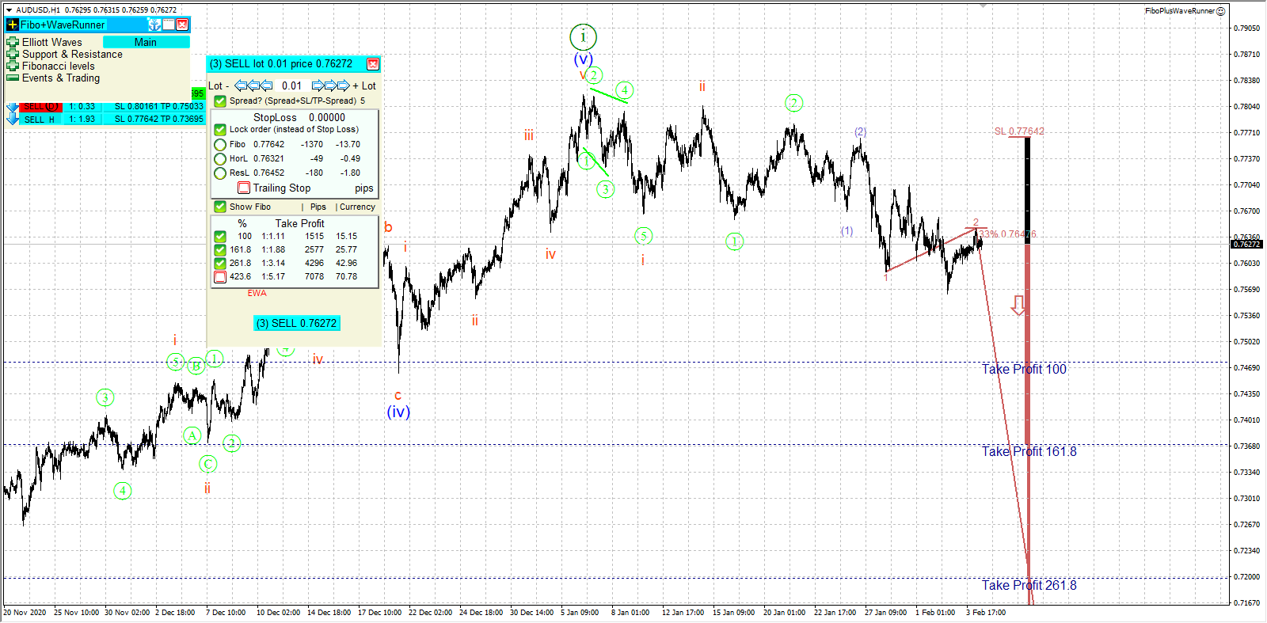
Shows the Trailing Stop setting with a value of 600 pips.
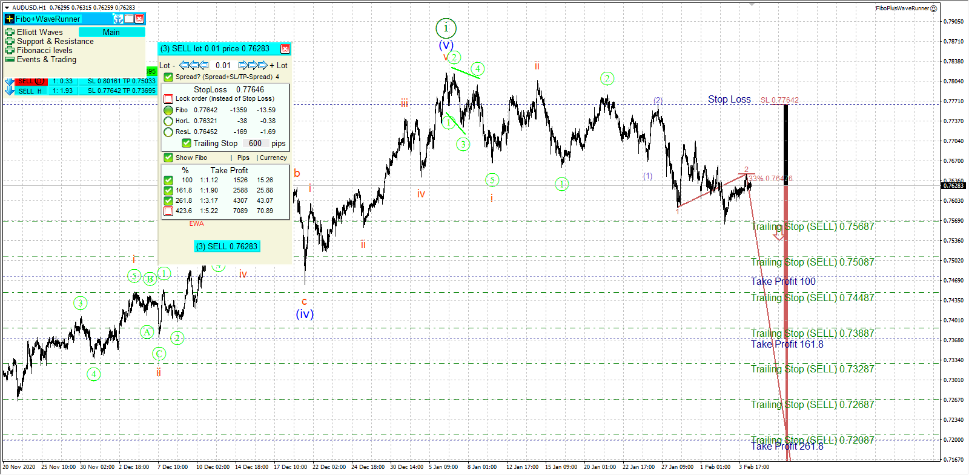

“Buy” button.

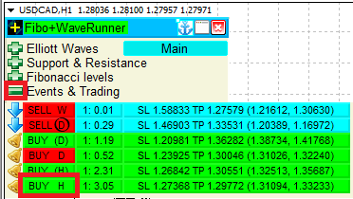
“Events & Trading” Button.
“Buy”, “Sell” buttons. Opening orders.

Lot - 0.01, Spread, Fibo, show Fibo. Visually shown are 3 orders with targets (TP0, TP1, TP2).
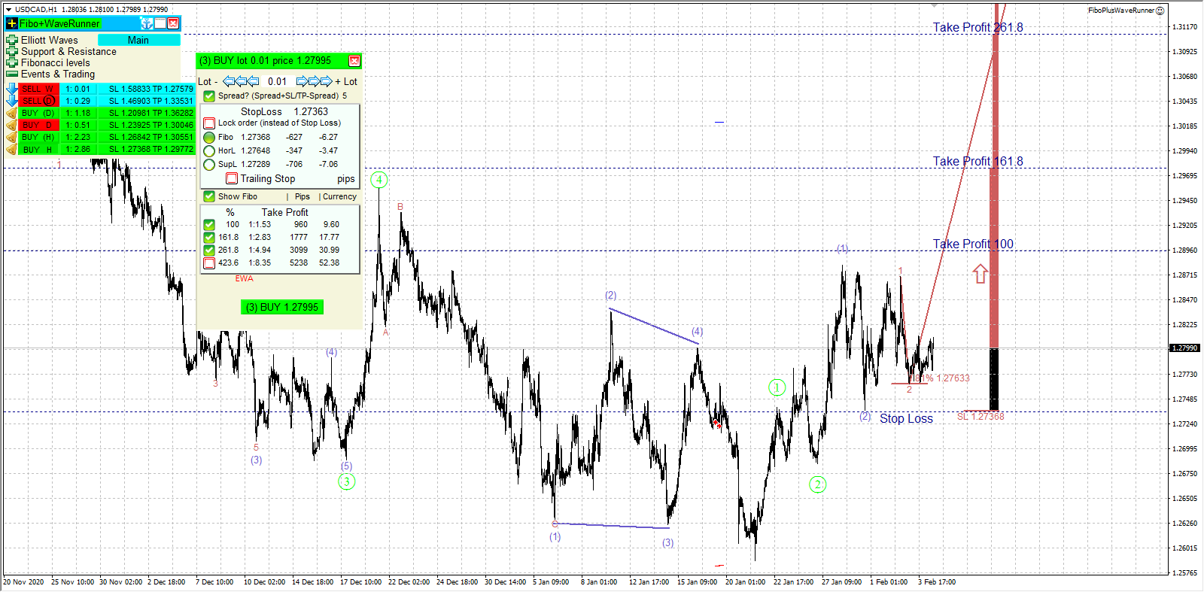
Shows the Trailing Stop setting with a value of 700 pips.
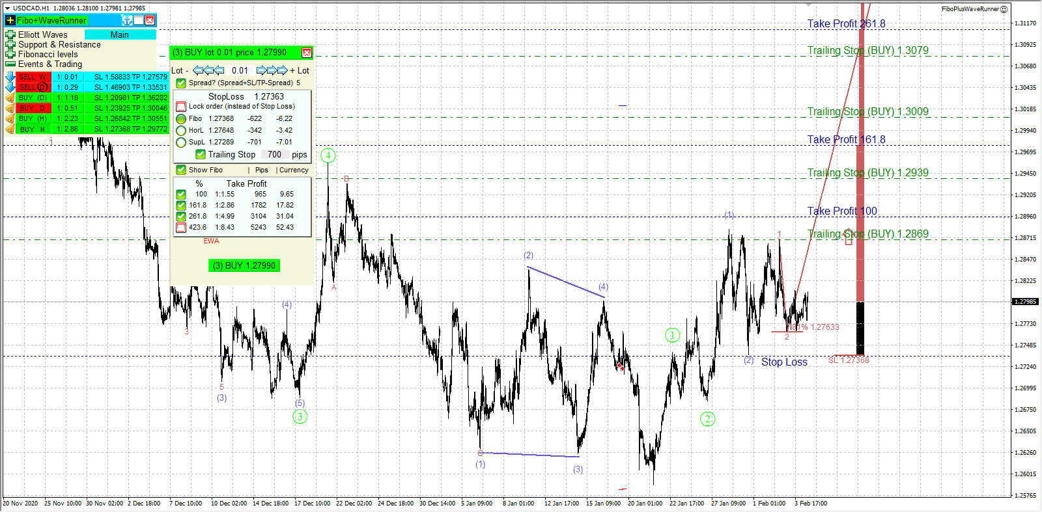

Auto trading.
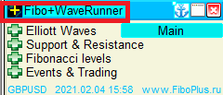
“Fibo + WaveRunner” button or icon .
Enabling / disabling auto trading mode

The usual parameters. Lot - 0.01, Spread. 2 orders with targets (TP0, TP1).
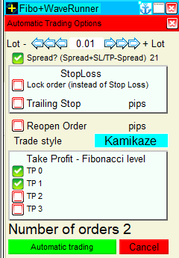

Setting a Trailing Stop with a value of 600 pips. Reopening with a value of 500 pips.
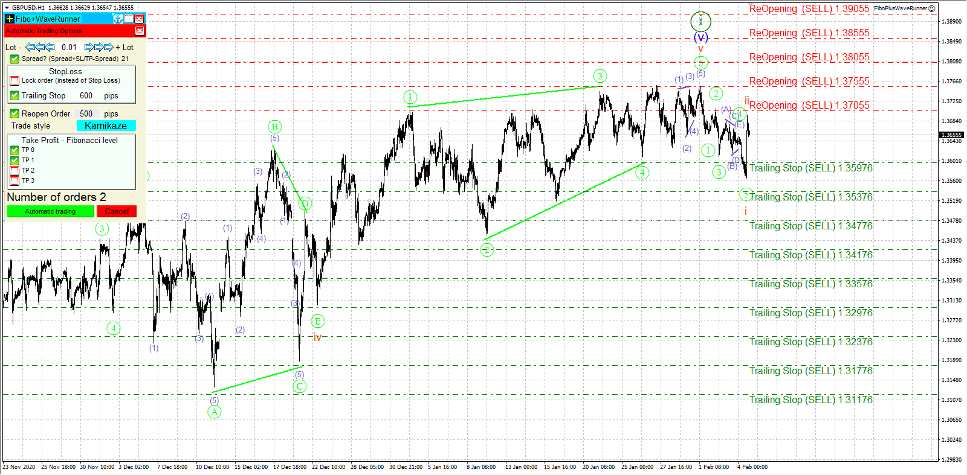

Parameters
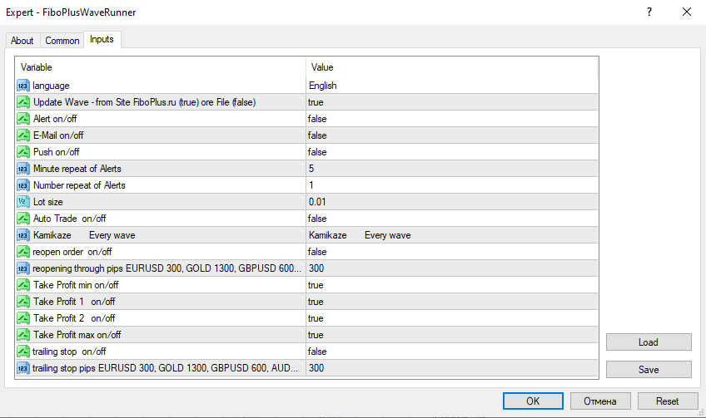
- Language (Russian, English, Deutsch, Espanol, Portugues)
- Update Wave - (true) updates of the wave markings on the chart from the website or (false) – through the exchange file (in any electronic way)
- Alert on/off - enable/disable alerts;
- E-Mail on/off - send alerts to E-Mail;
- Push on/off - send alerts via Push notifications
- Minute repeat of Alerts - the number of minutes to repeat alerts
- Number repeat of Alerts - the number of alert repetitions
- Lot size
- Auto trade on/off
- trading options:
    - Conservative - wave 3
    - Medium - wave 3, 5
    - Optimal - wave 3, 5, C
    - Active - wave 2, 3, 4, 5, A, C
    - Aggressive - wave 2, 3, 4, 5, A, B, C
    - Kamikaze - Every wave
- reopen order on/off
- reopening (reopening through pips GOLD 1000-1300 (0.01 pips) EURUSD 300 (0.00001 pips) GBPUSD 500 – 600, AUDUSD - 300). Reopening orders after the required number of points.
- Take Profit min on/off – TP 0 (take profit)
- Take Profit 1 on/off - TP 1 (take profit 1)
- Take Profit 2 on/off – TP 2 (take profit 2)
- Take Profit max on/off – TP 3 (take profit) max on/off
- Trailing stop on/off - (Turn on, turn off). Warning: when this mode is enabled, it is problematic to achieve the goals TP 1, TP 2, TP 3. It is recommended to enable it when you think it is time to start closing orders.
- Trailing stop pips - value in points for Trailing stop - GOLD 1300 (0.01 pips) EURUSD 300 (0.00001 pips) GBPUSD 500. Works for all orders opened by an Expert Advisor (both in manual and automatic modes). The Trailing stop value can be changed any number of times. Trailing stop will be triggered the first time when profit - Trailing stop> 0, that is, the order is transferred to no loss, and then follows the price. The recommended value is the same as reopening.

Reopening example for EUR / USD
Horizontal support / resistance levels can be used as a guide
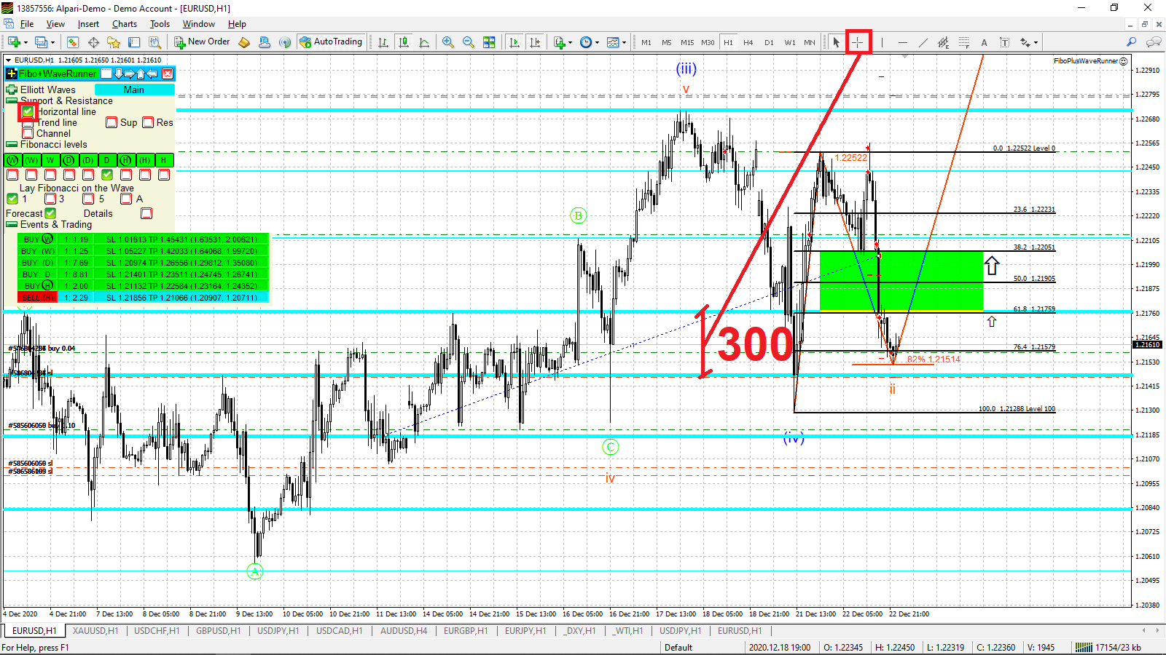

Reopening example for GBP/USD
Horizontal support / resistance levels can be used as a guide
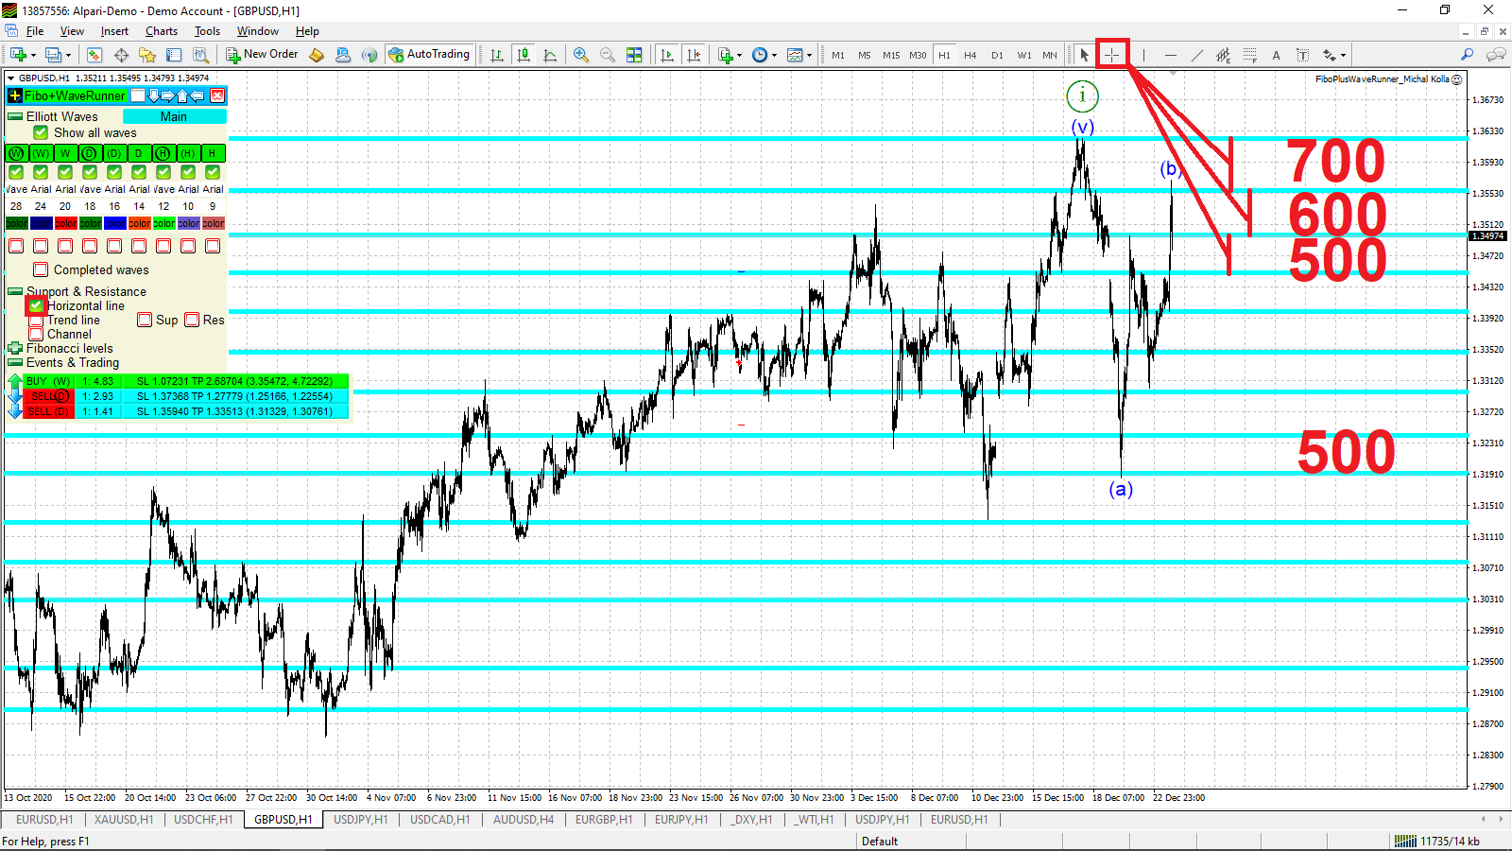

Video

FiboPlusWaveRunner
https://www.mql5.com/ru/market/product/59074

Watch the video
https://www.youtube.com/watch?v=NjjWWJtnSU8
+ testing
https://www.youtube.com/watch?v=ccFg4KllL00
full testing
https://www.youtube.com/watch?v=yJZMcWJDI-M

Questions and answers

Wave counting update.
Updated at least once a day.
A check for a new update is performed every hour.
A forced check for a new update is performed every time the timeframe is changed.

The size of the deposit. Lot volume
It is desirable to have $ 1,000 for each instrument (symbol) traded.
Lot 0.01.
For each enabled TP 0, TP 1, TP 2, TP 3, a separate order with its own parameters is opened.
How many signals, how many times orders will be opened
2 orders are immediately opened at TP0, TP1 + 2 more orders for each other available signal.
For example,
on EURUSD at the point 2020.12.30 16:00
Settings
- Lot 0.02
- TP 0, TP 1
- trading options – Kamikaze.
4 * 2 = 8 orders were opened.
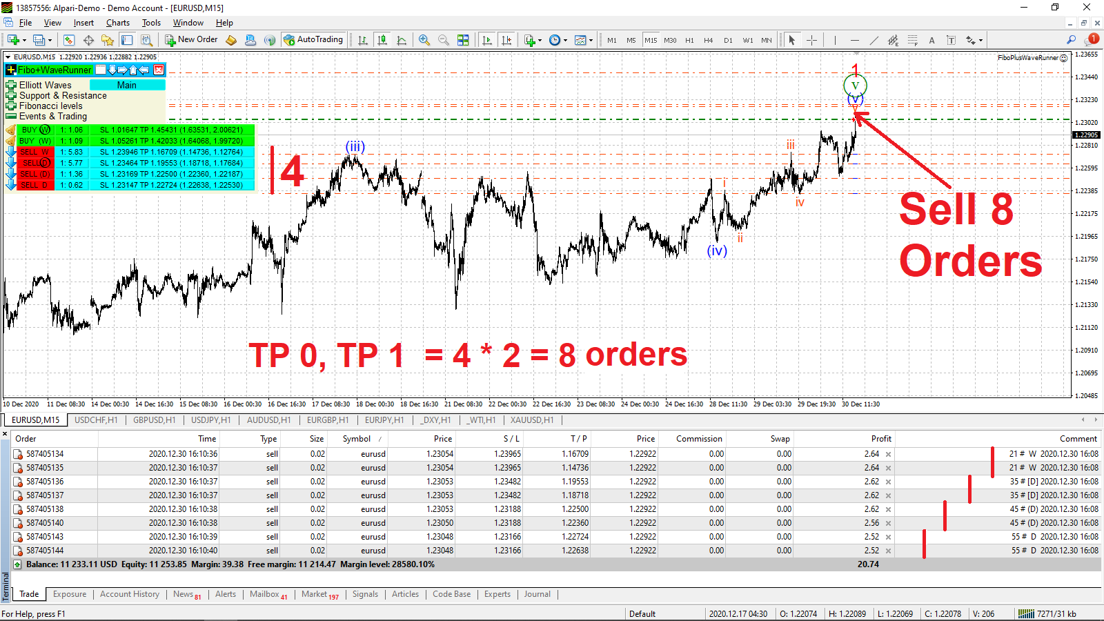

After purchasing the FiboPlusWaveRunner Expert Advisor, is it enough to connect it to the instrument with the same default settings?
for each instrument its own settings
♣ reopening (reopening through pips GOLD 1000-1300 (0.01 pips) EURUSD 300 (0.00001 pips) GBPUSD 500 – 600, AUDUSD - 300).
♣ Trailing stop pips GOLD 1300 (0.01 pips) EURUSD 300 (0.00001 pips) GBPUSD 500 – trailing stop in points. The recommended value is the same as reopening.

Which of the following pairs EURUSD, GBPUSD, AUDUSD, XAUUSD (GOLD), EURGBP, USDCAD, USDCHF, EURJPY, USDJPY, GBPJPY, OIL WTI, SPX 500 is most recommended for trading with your Expert Advisor?
We must look at the markup.
Where, of course, trade.
Do not trade in correction (letters).
The biggest profit is in the 3rd wave.

What to do, if wave counting is not shown on the instrument (symbol)? Is it on the list of 12 pairs, is the display of historical and current waves enabled?
Не все брокеры одинаково именуют торгуемые инструменты (символы).
Not all brokers give the same name to the traded instruments (symbols).
For example: XAUUSD (GOLD), SPX 500 (US 500), etc.
Various prefixes are added.
In this case, send a screen with your tools to me at msm_club@mail.ru
CTRL + M (Market Watch)
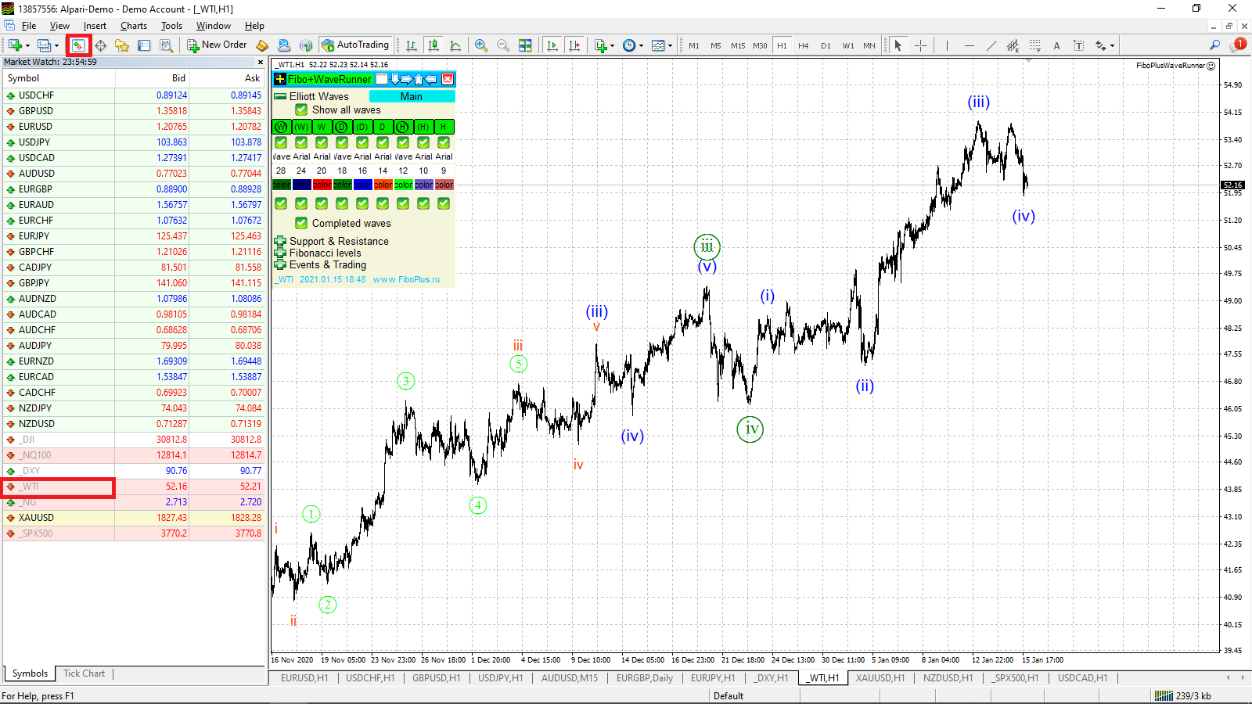

How do you know when an auto trade is working?
Before the button «Fibo + WaveRunner» there is an icon .
When the auto trading mode is on, a dot appears in the corner of the square .
The point with each incoming tick begins to move clockwise to the next corner of the icon .
And so on all corners of the square .
A message with parameters appears in the Experts window
*** automatic trading works *** lot = 0.01 orders = 2 TP 0 TP 1 reopening = 300 trailing stop = 300
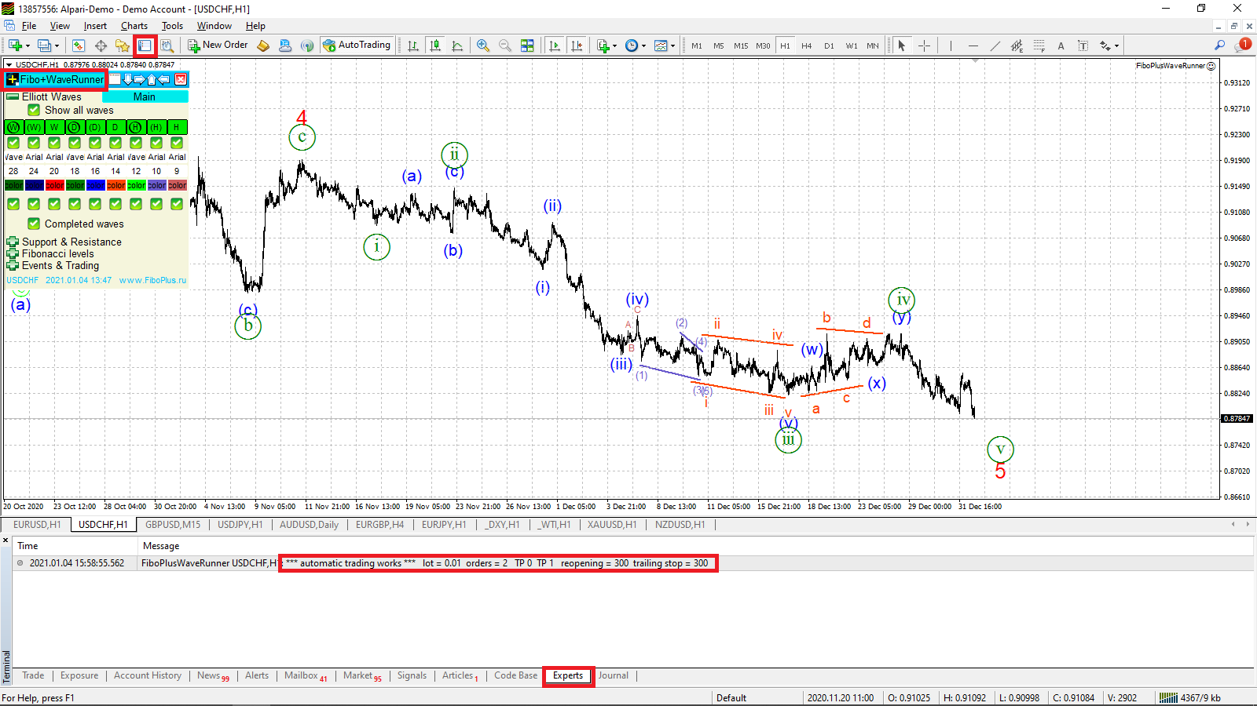

Accordingly, when the auto trading mode is disabled, a message will appear in the Experts window
*** auto trade disable ***

Automatic trading no work?
I applied "FiboPlusWavesRunner" to my chart.
I downloaded the manual, added "https://www.fiboplus.ru/" to the list of URLs to allow WebRepuest, and set up the software as described in the manual.
However, the white dot does not appear in the corner of the icon in front of the Fibo + WaveRunner button.
How can I get the white dot to appear in the corner of the icon so that automatic trading will work?
It is necessary to enable the settings of the MetaTrader4 itself
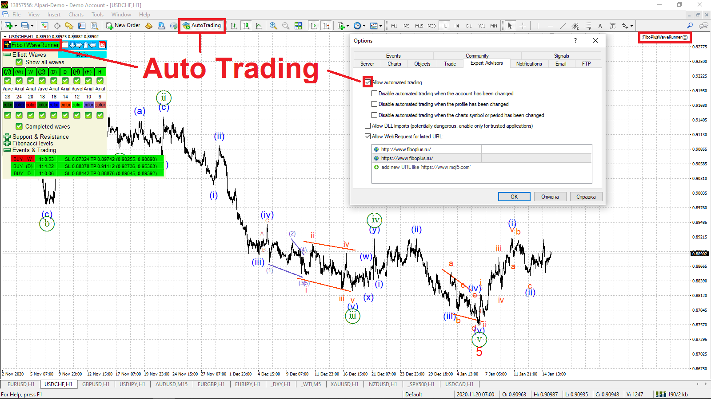
Add One Click Trading.
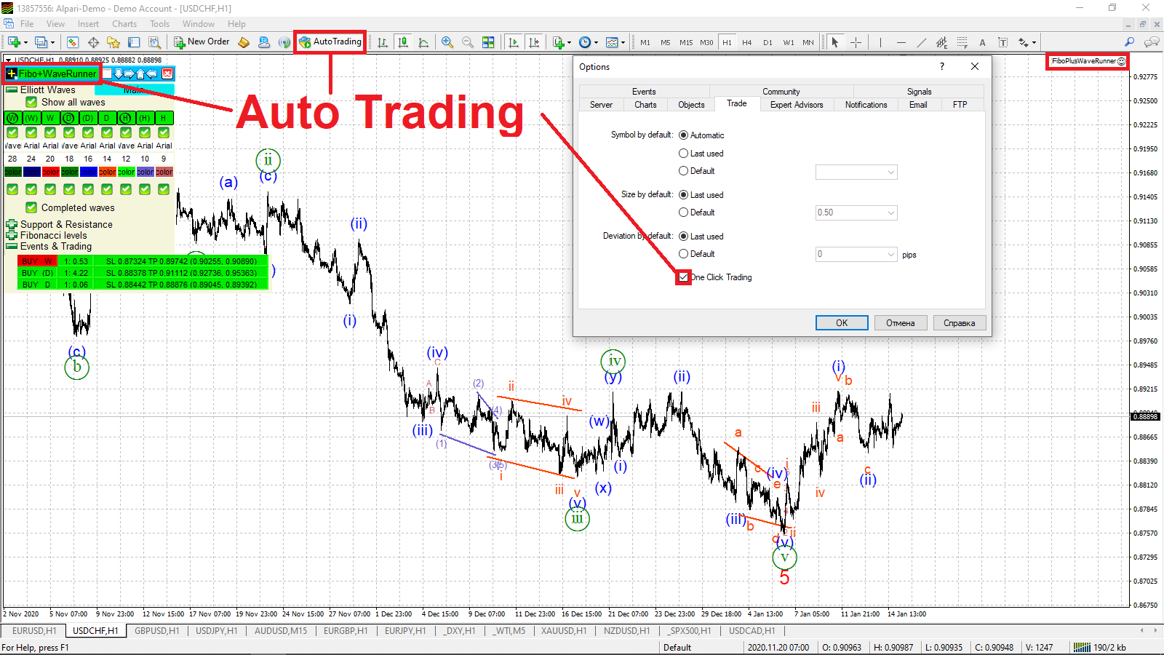

Opening orders for auto trading.
There are current trading signals ("Events & Trade" button),
Trading signals in auto trading are triggered if no more than 12 bars (candles) have passed since the start of the signal.
After that, they are not available for auto trade.
However, if you switch to a larger timeframe (for example, from H1 to H4), then, accordingly, a smaller number of bars will pass from the beginning of the candle and for auto trading, signals will again be available.
If orders for the current trading signals are already open, then switching to a higher timeframe does not open new orders, except for the case with the reopening parameter

Why didn't the signal work for me during auto trading on M15, but did it open when changing to the H1 timeframe?
The main (working) timeframe is H1 and higher.
However, no one bothers you to trade on the M15.
On M15, you had more than 12 bars (candles), so the signal for the M15 timeframe is already considered outdated.
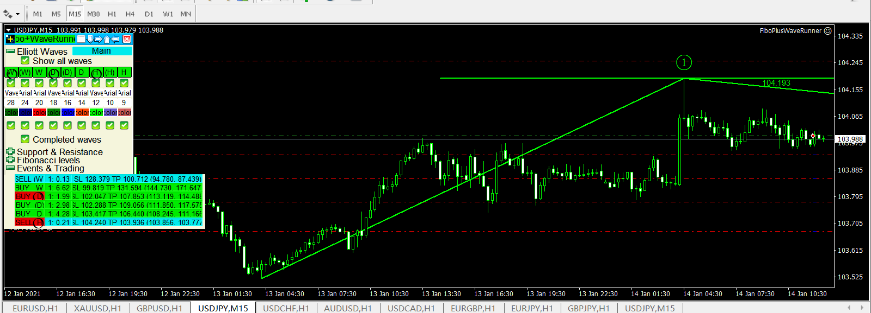
When switching to the H1 timeframe, the bars (candles) became less than 12 and the signal triggered.
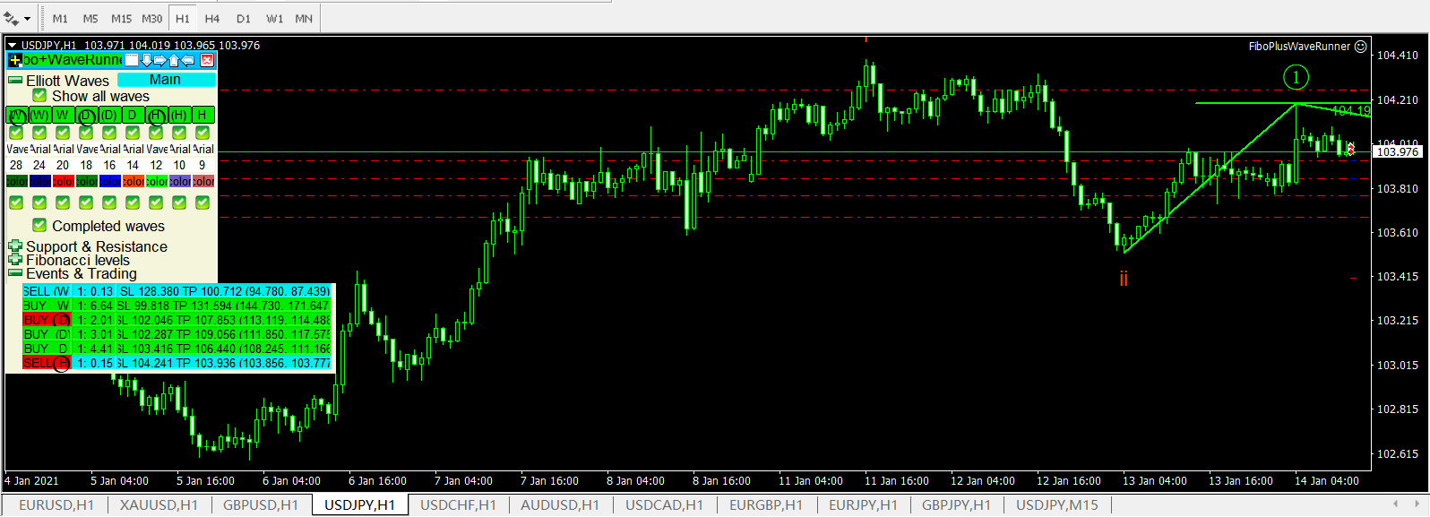

Closing an order when TP 0 is reached.
For other orders (TP1, TP2, TP3), which are therefore opened to the signal, the stop loss is set at no loss.
Stop loss is set at the received half of the profit of the order with TP0.
according to the formula:
(opening price - closing price of an order with TP0) / 2 + opening price.

The EA is displayed on the chart differently from the description on the website.
Most likely, you do not have the Arial font installed or it is not the full version.
Most often, this happens when installed on a VPS server.
You need to download and install the Arial font.
  - Download font https://www.FiboPlus.ru/arial.rar
  - Place the font file anywhere on the disk.
  - Unzip (winrar, unzip) the arial.rar file
  - Click on each received file 2 times - INSTALL () font

Are those EA auto open the order by placing BUY / SELL, or the user need to open it by manually like u show in earlier of your video? "in minutes 1:33" im so confused
FiboPlusWaveRunner Expert. Automatic and manual trading.
1. Automatic trading.
2. Manual trading.
3. Automatic and manual trading together.

Download description
https://www.FiboPlus.ru/FiboPlusWaveRunner_readme-eng.pdf
in pdf format - opens in the browser
https://www.FiboPlus.ru/FiboPlusWaveRunner_readme-eng.docx
in word format - will offer to save

